# 🇬🇧 Feb 4: Commute chaos, culture flex

Feb 4, Wed • AQI 26

**In this edition:**

* London's largest theatre ever
* Train derailment
* BTC tickets on sale

## Spotlight

## 

### “Do not travel” warning

**Background:** A Southern [train derailed](https://link.londonsummary.com/ls-4-feb-26--h1-1-train-derailed) inside Selhurst depot in south-east London, while a separate signalling fault hit the key corridor between London Blackfriars and Norwood Junction just before the morning peak. The timing, on one of the UK’s busiest routes, caused disruption across Southern, Thameslink and Gatwick Express services, with knock-on effects for parts of the London Overground’s Windrush line.

**What happened:** Two failures at once create a network pile-up. Trains get stuck, routes are blocked or throttled, and crews and rolling stock end up in the wrong places for later services. Govia Thameslink Railway issued a [rare “do not travel](https://link.londonsummary.com/ls-4-feb-26--h1-2-rare-do-not-travel)” notice to prevent overcrowding and manage safety, then lifted it once limited services and crowd controls were in place. Even after lines reopen, delays and last-minute cancellations can persist until the fleet and staff are rebalanced.

**Implications:** Expect messy commutes into the evening, especially on Brighton Main Line services. Ticket acceptance on the Underground, buses, Elizabeth line and some local operators helps, but crowding and missed connections still cost time and money. Overground disruption is expected to linger into Thursday lunchtime on affected sections.

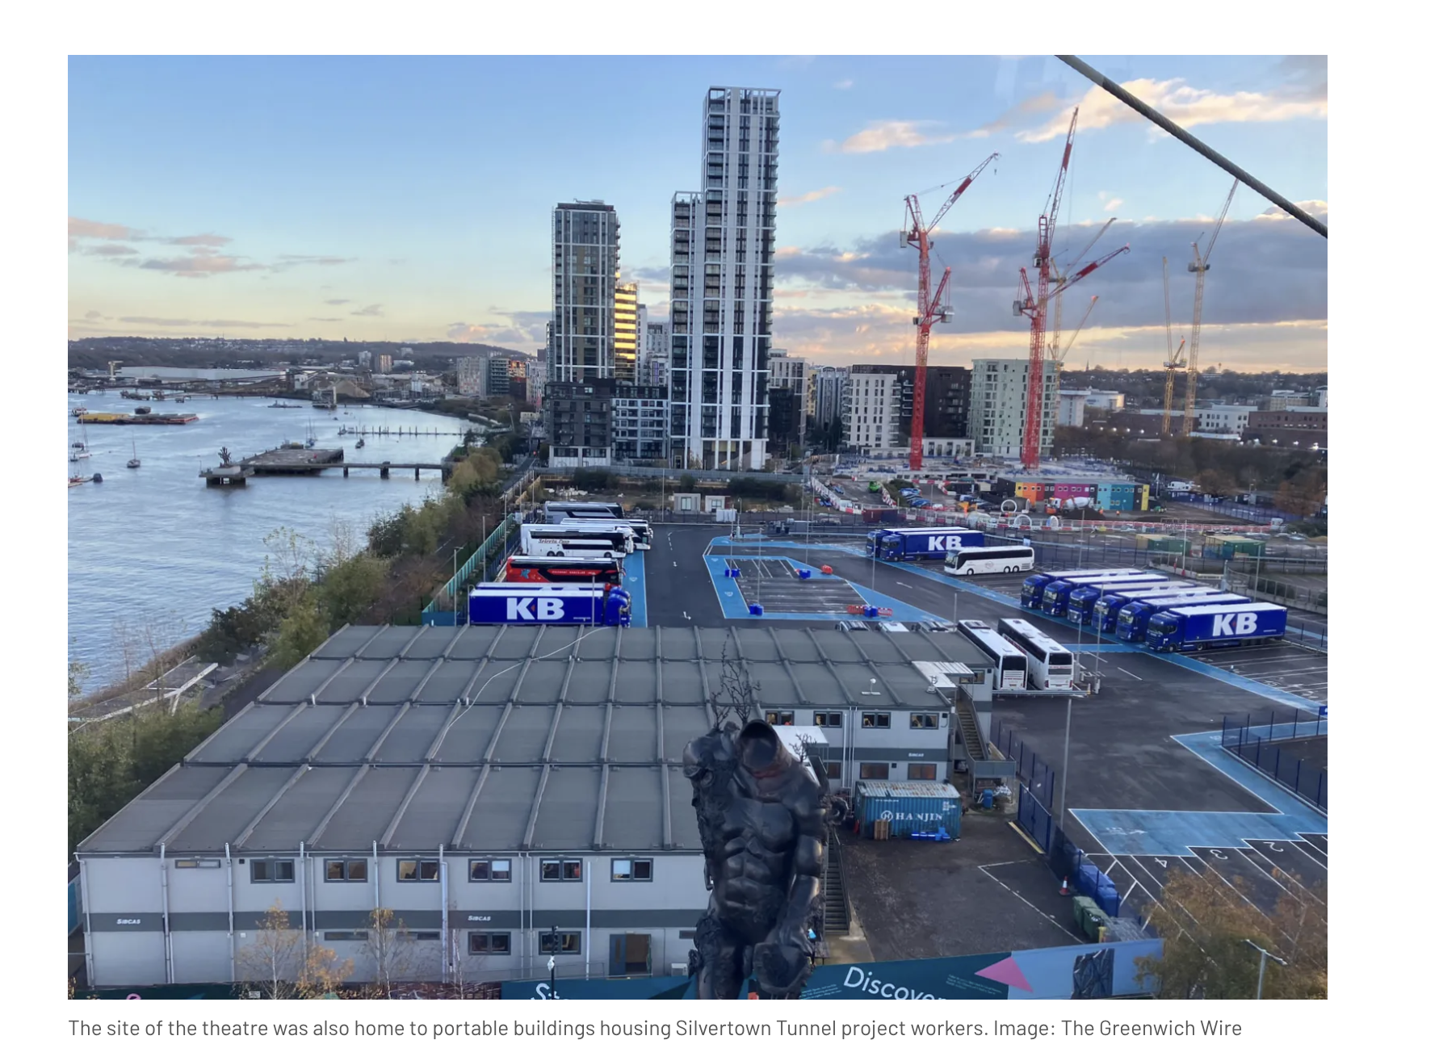

### London’s largest theatre

**Background:** Greenwich Council has [approved plans](https://link.londonsummary.com/ls-4-feb-26--h2-3-approved-plans) for a new 3,000-seat Troubadour theatre on the eastern side of the Greenwich Peninsula in south-east London. Designed as two 1,500-seat auditoriums, it would become London’s largest dedicated theatre by capacity, overtaking the 2,359-seat London Coliseum in the West End.

**What next:** Troubadour, which already operates venues in Wembley Park and Canary Wharf, says the new site will expand London’s cultural offer and enable bold, large-scale live productions. Construction is expected to begin in June and take around nine months.

**Local representation:** Planning permission is temporary for 10 years, with the land near the cable car station ultimately earmarked for residential towers under the wider masterplan. Local residents’ representatives supported the scheme and urged that school access be included in the conditions. Troubadour says community benefit is a priority, with its trust funded by a 50p per-ticket levy to support workshops and ticket schemes for schools and charities.

## What’s on

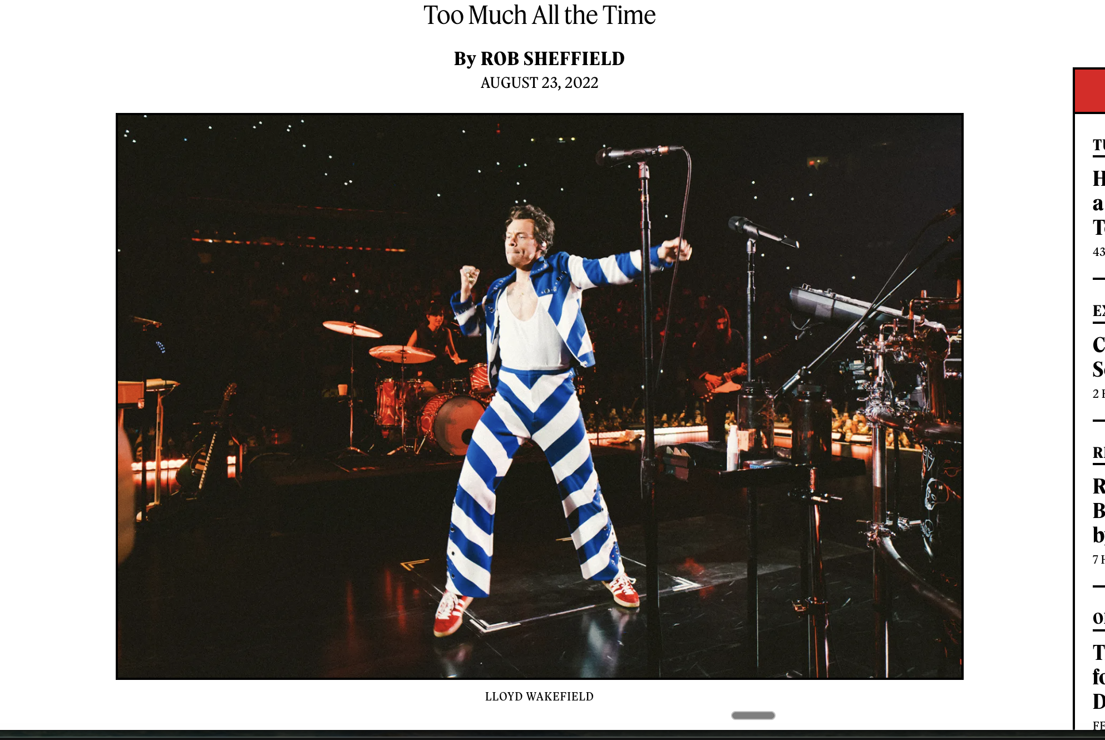

**Harry Styles tickets now available**

Harry Styles is set to play a London residency at Wembley Stadium in summer 2026 as part of his Together, Together tour, with multiple dates beginning 12 June 2026 (and a longer run advertised across mid-June to early July), supported by Shania Twain.  
[**12th June onwards, tickets from**](https://link.londonsummary.com/ls-4-feb-26-wo-4-12th-june-onwards-tickets-from)  [**£**](https://link.londonsummary.com/ls-4-feb-26-wo-5-)[**105**](https://www.stubhub.ie/harry-styles-tickets/performer/1521417/?valueMessaging=true&utm_medium=cpc&utm_source=google&utm_campaign=IE-EN-%5BS%5BPER_1521417%5D_G3%3AHarry%20Styles_P-Max&gad_source=1&gad_campaignid=23517164775&gbraid=0AAAAAD0XtVKk4ySpLB5FAlllYiJIks8Ax&gclid=Cj0KCQiA-YvMBhDtARIsAHZuUzI7cuyfL8cUaNK_ZK5_Pcz4kuu33pjFdTNB-ctf3rdLrWJsLzpxqLcaAn9hEALw_wcB)



**BTS tickets are on sale**BTS are scheduled to bring their 2026 world tour (“ARIRANG”) to Tottenham Hotspur Stadium in London for two shows.

[**6 and 7 Jul, tickets starting £300**](https://www.viagogo.es/Entradas-Conciertos/Pop-Rock/Asian-Pop/Korean-Pop/BTS-Entradas/E-160262279?backUrl=%2FEntradas-Conciertos%2FPop-Rock%2FAsian-Pop%2FKorean-Pop%2FBTS-Entradas&quantity=2)

## Long story short

### Politics

[Sir Keir Starmer faced intense pressure in Parliament over the “Mandelson files”](https://link.londonsummary.com/ls-4-feb-26-lss-h1-8-sir-keir-starmer-faced-intense-pressure-in-parliament-over-the-mandelson-files) tied to Peter Mandelson’s appointment as UK ambassador to the US and his links to Jeffrey Epstein. After Labour MPs pushed back, the government agreed that any documents withheld on national security or international-relations grounds would be reviewed by Parliament’s Intelligence and Security Committee, not ministers. The Commons debate was extended to 7pm.

**The UK Treasury is offering** [**voluntary exit packages of up to £100,000**](https://link.londonsummary.com/ls-4-feb-26-lss-h1-9-voluntary-exit-packages-of-up-to-100-000) **to encourage staff to leave**, as part of plans to cut around 300 jobs by 2030 from a workforce of roughly 2,100. The move supports a wider government push to reduce Whitehall administrative costs by 16%. If take-up is low, redundancies could follow across offices in London, Darlington, Norwich and Edinburgh.

### Business

[Beazley, the UK specialist insurer known for cyber-attack cover as well as fine art and luxury yacht insurance, has agreed an £8bn takeover by Zurich](https://link.londonsummary.com/ls-4-feb-26-lss-h2-10-beazley-the-uk-specialist-insurer-known-for-cyber-attack-cover-as-well-as-fine-art-and-luxury-yacht-insurance-has-agreed-an-8bn-takeover-by-zurich) in an “agreement in principle”. Zurich raised its bid after an earlier approach was rejected, offering up to £13.35 per share (mainly cash), about a 60% premium to Beazley’s pre-interest share price. The deal would deepen Zurich’s access to Lloyd’s of London and marks another major exit from the London market.

[A City of London Corporation report warns women in tech and financial services face higher AI and automation displacement risk](https://link.londonsummary.com/ls-4-feb-26-lss-h2-11-a-city-of-london-corporation-report-warns-women-in-tech-and-financial-services-face-higher-ai-and-automation-displacement-risk) than men, especially “mid-career” women being screened out by rigid, sometimes automated CV filters that penalize career breaks. The report urges employers to reskill women in non-technical and clerical roles, predicting about 119,000 such jobs could be automated over a decade. It argues upskilling could reduce redundancy costs and ease persistent digital vacancies and growth losses.

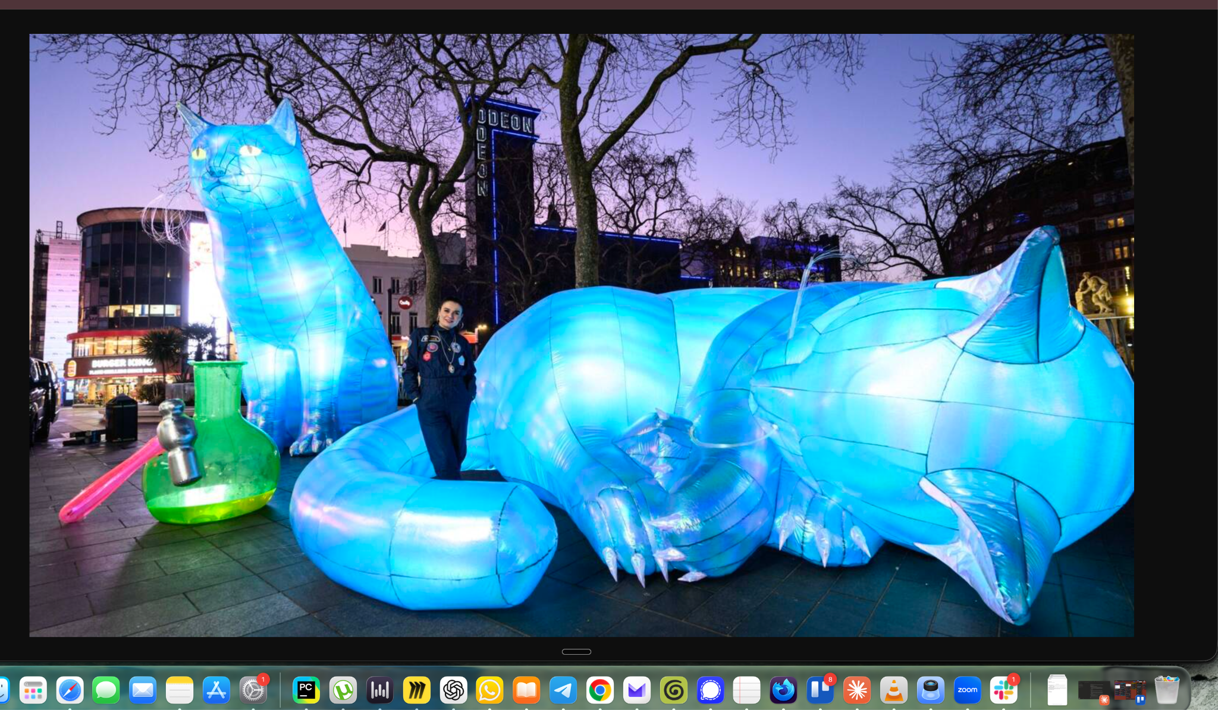

### Art & culture

[Art After Dark is back in London’s West End from 3 to 10 Feb 2026](https://link.londonsummary.com/ls-4-feb-26-lss-h3-12-art-after-dark-is-back-in-london-s-west-end-from-3-to-10-feb-2026), turning the area into a week of free public art, late-night museum and gallery openings, and music-led events. Headlining is Lakwena Maciver’s “Rise and Shine” installation at Piccadilly Circus, plus nightly art on the Piccadilly Lights. Highlights include a £5 after-hours National Gallery party (5 Feb) with DJ sets, and discounts at local bars and restaurants.

[Guarding released Margaret Calvert’s profile.](https://link.londonsummary.com/ls-4-feb-26-lss-h3-13-guarding-released-margaret-calvert-s-profile) A quietly iconic British design figure whose work shapes daily life, especially the UK’s modern road-sign system and the Transport typeface, created with Jock Kinneir. From her Islington studio, she describes starting when “graphic design” barely existed, insisting on clarity through testing and iteration despite pushback. The profile traces her public-design legacy, modest personality, and decades teaching at the Royal College of Art.

### Misc

[Earth Hour returns on 28 March 2026, with London landmarks switching off non-essential lights for an hour.](https://link.londonsummary.com/ls-4-feb-26-lss-h4-14-earth-hour-returns-on-28-march-2026-with-london-landmarks-switching-off-non-essential-lights-for-an-hour)

[Leadenhall Market’s 15th annual Pancake Day Race runs 13 Feb afternoon, with teams flipping for the Golden Frying Pan.](https://link.londonsummary.com/ls-4-feb-26-lss-h4-15-leadenhall-market-s-15th-annual-pancake-day-race-runs-13-feb-afternoon-with-teams-flipping-for-the-golden-frying-pan)

[Grade II-listed Art Deco Ibex House near the Tower will become a 382-room hotel, opening 2028](https://link.londonsummary.com/ls-4-feb-26-lss-h4-16-grade-ii-listed-art-deco-ibex-house-near-the-tower-will-become-a-382-room-hotel-opening-2028)

[Hackney’s Viktor Wynd Museum of Curiosities was named the UK’s “weirdest” attraction, packed with bizarre oddities.](https://link.londonsummary.com/ls-4-feb-26-lss-h4-17-hackney-s-viktor-wynd-museum-of-curiosities-was-named-the-uk-s-weirdest-attraction-packed-with-bizarre-oddities)

## Did you know

London has more than one “Chinatown.” The famous one is near Leicester Square, but the city has multiple [historic](https://link.londonsummary.com/ls-4-feb-26-dyk-18-historic) clusters of different communities across zones.

Image credits: The Guardian, Secret London, Art of London, Timeout London, Rolling Stones, BBC